**CPE 1140**

**1. LAB NUMBER: 6**

**2. TITLE: Thevenin Equivalent Circuit Analysis**

**and Maximum Power Transfer Theorem**

**3. OBJECTIVES:**

After completing this lab, the student will be able to:

a. measure the Thevenin equivalent resistance Rth, b. measure the Thevenin equivalent voltage Eth,

c. verify the Thevenin’s theorem,

d. verify the Maximum Power Transfer theorem.

**4. EQUIPMENT:**

DC Power Supply: Uni PS-2303

Digital Multimeter: RIGOL DM 3058E

Experimenter board (C.A.D.E.T.) or a Breadboard

Multisim Software

**5. COMPONENTS:**

2 - 100 Ω ½ watt 5% Resistor

2 - 470 Ω ½ watt 5% Resistor

2 - 1k Ω ½ watt 5% Resistor

3 - 2k Ω ½ watt 5% Resistor

1 - 2.7k Ω ½ watt 5% Resistor

**6. TEXT REFERENCE:**

Circuit Analysis: Theory and Practice (5th Edition): A.H. Robbins and W.C. Miller

Section 2.6: Measuring Voltage and Current

Section 3.7: Measuring Resistance – the Ohmmeter

Section 9.2: Thevenin’s Theorem

Section 9.4: Maximum Power Transfer Theorem

**7. PRE-LAB ASSIGNMENT:**

Study Fig. 1 and do the following calculations:

(Attach all your calculations at the end of your report as an Appendix)

Figure 1:

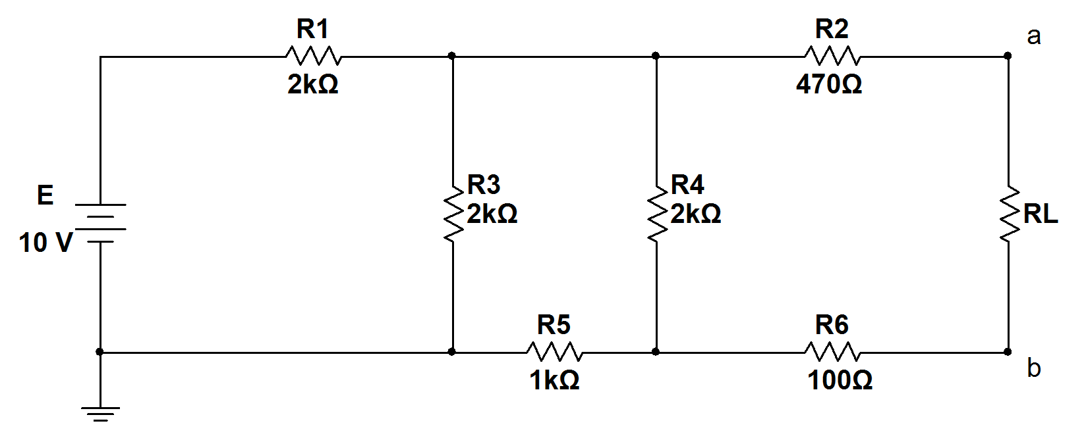

1. Redraw the circuit of Fig. 1 with the load RL removed. Replace the source E with a short circuit. Calculate the Thevenin equivalent resistance Rth as seen into the circuit from terminal (a-b). Record your result in Table 1.

R1 || R3 = 2000*2000/4000 = 1000Ω

R1 || 3 + R5 = 1000 + 1000 = 2000Ω

R (((1 || 3) + 5) || R4­ = 2000*2000/4000 = 1000Ω

R (((1 || 3) + 5) || 4) + R2 + R6 = 1000 + 470 + 100 = 1570Ω

1. Insert the source E in the circuit and calculate the Thevenin equivalent voltage Eth at the terminal (a-b) without the load RL. Record your result in Table 1.

R5 +R4 = 1000+2000 = 3000Ω

R 5 + 4 || R3 = 3000*2000/5000 = 1200Ω

V target = R target / ∑ R * V source = 1200/3200 * 10 = 3.75V

V target = R target / ∑ R * V source = 2000/3000 * 3.75 V = 2.5V

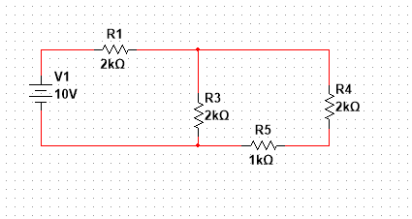

Table 1:

Rth =1.57kΩ

Eth =2.5V

1. Draw the Thevenin equivalent circuit just derived with the load RL attached. Use it to calculate the load current IL for various load resistances as in Table 2. Calculate the corresponding Power dissipated in each load. Record your result in Table 2.

V= I * R

V Th / (R Th + R load) = I Th

P = I * V

P = I2 * R

Table 2:

|  |  |
| --- | --- |
| IL (470) = 1.225 mA | P (470) = 0.705 mW |
| IL (1k) = 0.972 mA | P (1k) = 0.944 mW |
| IL (Rth) = 0.796 mA | P (Rth) = 0.994 mW |
| IL (2.7k) = 0.585 mA | P (2.7k) = 0.924 mW |

**Initial value measurements:**

|  |  |  |  |
| --- | --- | --- | --- |
| Resistor label | Resistor value Ω | Resistors measured Ω | Resistor rangesΩ |
| R1 | 2000 | 1944.96 | 1900.000-2100.000 |
| R2 | 470 | 465.67 | 446.500-493.500 |
| R3 | 2000 | 1982.71 | 1900.000-2100.000 |
| R4 | 2000 | 1969.88 | 1900.000-2100.000 |
| R5 | 1000 | 989.33 | 950.000-1050.000 |
| R 6 | 100 | 98.211 | 95.000-105.000 |
| R L1 | 470 | 463.61 | 446.500-493.500 |
| R L 2 | 1000 | 984.45 | 950.000-1050.000 |
| R L th | 1570 | 1547.84 | 1491.500 – 1648.500 |
| R L 4 | 2700 | 2657.3 | 2565.000-2835.000 |
| R 100 | 100 | 98.834 | 95.000-105.000 |

|  |
| --- |
| Full circuit values |
| IL (470) = 1.251 mA |
| IL (1k) = 0.994 mA |
| IL (Rth) = 0.81372 mA |
| IL (2.7k) = 0.59903 mA |

|  |  |
| --- | --- |
| Full circuit values | Thevenin equivalent circuit |
| Rth=1550.96Ω | R th = 1555.33Ω |
| ES= 10.0015V | null |
| Eth = 2.5221V | V th =2.4999 V |

|  |  |
| --- | --- |
| Full circuit values | Thevenin equivalent circuit |
| IL (470) = 1.251 mA | IL (470) = 1.2367 mA |
| IL (1k) = 0.994 mA | IL (1k) = 0.983 mA |
| IL (Rth) = 0.81372 mA | IL (Rth) = 0.80496 mA |
| IL (2.7k) = 0.59903 mA | IL (2.7k) = 0.5931 mA |

|  |  |
| --- | --- |
| Calculated power transfer | Measured power transfer |
| P (470) = 0.705 mW | P (470) = 0.718 mW |
| P (1k) = 0.944 mW | P (1k) = 0.966 mW |
| P (Rth) = 0.994 mW | P (Rth) = 1.007 mW |
| P (2.7k) = 0.924 mW | P (2.7k) = 0.949 mW |

**F – Multisim simulations:**

n) Create a Multisim circuit similar to Fig. 1 (original circuit) with:

1. One Voltmeter to measure Load voltage.

2. One Ammeter to measure load current with RL = 1kΩ.

**9. LAB REPORT REQUIREMENT:**

Your team’s Lab Report should contain the followings:

**A Cover Page** with Lab Number, Lab Title, Team members’ Names and Date.

**Result Pages** with:

**A – Measure Load Current with the Original Circuit:**

Results:

Show a copy of Table 3.

Discussions:

1. Compare the result in Table 3 for 1kΩ with that from Multisim.
2. Explain any differences.

**B – Measure Rth and Eth:**

Results:

Show a copy of Table 4.

Discussions:

1. Answer 8(g).
2. Explain any differences.

**C – Measure Load currents with the Thevenin Equivalent Circuit:**

Results:

Show a copy of Table 5.

Discussions:

1. Answer 8(k).
2. Explain any differences.

**D – Power calculations:**

Results:

Show a copy of Table 6.

Discussions:

1. Answer 8(m)
2. Explain any differences.
3. Which load resistance dissipates the largest power?

**E - Conclusion:** (*it helps to compare your prelab with measured results*)

1. What conclusion can you make about the accuracy of Thevenin’s equivalent circuit?
2. What conclusion can you make about the validity of the Maximum Power Transfer Theorem?
3. Are all the Lab objectives met? Explain if some are not.

**Appendix**: Attach a printout of **Multisim** simulation and all **Pre-Lab calculations**.

**Circuit Layout**

